

STANDARD OPERATING PROCEDURE

TFP Blastocyst Grading External Quality Assurance Scheme

PRINTED COPIES OF THIS DOCUMENT ARE UNCONTROLLED
PLEASE REFER TO Q PULSE FOR THE LATEST VERSION

DOCUMENT DETAILS
AUTHOR (NAME & JOB ROLE): |  |  | Lyndsey Zujovic, Group Director of Embryology
DOCUMENT APPLICABLE TO: |  |  | TFP GROUP (ALL)
DISTRIBUTION GROUP: |  |  | All Laboratory Staff
AMMENDMENT HISTORY
REVISION | ACTIVE DATE | CHANGES MADE
1.0 | 27/11/2020 | Initial release.
2.0 | 17/05/2022 | Mini-tab statistical analysis references removed.

Purpose
To describe the frequency of distribution, methods of preparation and presentation, scope of distribution, methods of analysis of data submitted and reporting of results. To define the process of preparing for, distributing and analysing submissions to the TFP Blastocyst Grading External Quality Assurance (EQA) Scheme.

Scope
Applicable to staff responsible for preparing, distributing and analysing the TFP Blastocyst Grading EQA Scheme.

Definitions
TL Time Lapse
ES+ EmbryoScope Plus
EQA External Quality Assurance

Responsibilities
            - Group Director of Embryology & EQA Coordinator
The group director of embryology alongside the EQA coordinator are responsible for preparing, distributing and analysing the EQA distributions. Distributions will be sent out four times per year. The Group Director of Embryology & EQA Coordinator is ultimately accountable for the implementation of this group-wide policy.
            - General Manager
The General Manager (GM) is accountable for the implementation of this clinic-wide process.
            - Laboratory Manager (Clinic)
The Laboratory Lead is responsible for ensuring that all relevant staff comply with the instructions given in this SOP. The Laboratory Lead is also responsible for ensuring that all relevant staff are trained in and understand the content of this SOP and that they are aware of the requirements that it contains.
            - Quality Manager
The Quality Manager is responsible for ensuring that all staff are aware of and comply with the requirements specified in this document. The QM is also responsible for ensuring all non-compliance with this SOP, or incidents occurring are properly investigated and any corrective action taken is recorded on QPulse.
            - All Staff
All staff are responsible for following the process laid out in this document, ensure they receive up-to-date training to enable safe working and to request further training if they feel it is required. Staff are also responsible for reporting any non-compliance or incidents occurring on QPulse and following up the outcome of any reported incidents/non-conformities.

Procedure

5.1 The following IT packages are required; Google Documents, Excel

5.2 A distribution is supplied quarterly by the Group Embryology Director to all laboratory heads within TFP. Dates should be set at the start of the year by the EQA Scheme Coordinator for distribution, return of results and reporting of results.

5.3 The EQA Scheme Coordinator prepares a distribution by collating images and videos of day 5 embryos from the ES+ patient database of slide images. Open the ES+ Embryo Viewer software. Select ‘View all slides’. Select embryos that haven’t been used before, this can be done by keeping a record of cycles used or by using insemination dates from the months since the last distribution. Work through these slides selecting embryo images from approximate grades A-F (5-7 of each grade). The aim is to have 35 images in the final selection but it is helpful to collect spares at this stage in case some are not suitable on further review. To increase the choice of earlier stage embryos (E and F) rewind the videos of more advanced blastocysts to assess their compaction and cavitation stages for suitability. Aim to select embryos located centrally in their wells (with the inner cell mass in clear focus where applicable) for inclusion. By moving the video back and forwards, select the optimal time point to capture the still image of the embryo and record the time for your reference.

5.4 Create a folder on the desktop of the ES+ PC to save images and videos into – labelled as TFP EQA Round ‘x’. Click ‘Video’ on the left-hand panel then in the ‘generate’ box enter the time of selection of optimal embryo image as the start and end time. Click ‘generate images’ then click ‘generate’. Click ‘save as’- ‘desk top’ ‘Round x’ ‘save’. To then generate a video for the same embryo, enter the start time as the start of embryo culture in TL and then end time as the time of the generated still image. Click ‘generate video’ then click ‘generate’ and save in the same subfolder as the still image to keep them linked as a pair. Rename subfolder as approximate grade e.g. E1, E2 etc. for ease of locating later. You can alter the focal plane of the image in the main viewer window to optimize image quality/field of view and this changes the focal plane in the video/image generator tab.

5.5 Move the images and videos to a standard work computer with a USB. There is a specific Google Docs/Google Drive account under the email address tfpembryograding@gmail.com. All of the images and videos for each round should be uploaded to Google Drive. From here they can be inserted into a new Google Slides presentation by clicking ‘insert’ ‘Google Drive’ then choosing the relevant image (see Figure 1). Next to the image insert the paired video by going to ‘insert’ ‘video’ ‘Google Drive’. Use the previous ‘Slides’ documents as a template with 5 theoretical patient groups of 7 images – each group with a range of grades. There does not need to be an equal number of each grade of embryo, but all grades should be represented. To make the utilisation analysis easier, ensure that each ‘patient’ has at least one embryo that would be suitable for cryopreservation.

To enable everyone with the link to access the video files this needs to be enabled for each individual file within Google Drive. Right-click on the video file, click ‘share’ then click ‘enable access for anyone with this link’ and repeat this for each video.

Then return to the finished Google Slides file and click ‘share’ which brings up a link that can be copied and pasted into the email for distribution to everyone in the EQA scheme. Send this link, along with a blank template Excel data entry file on to the Group Embryology Director for review and distribution. Up to 6 operators from each clinic can grade the embryos, enter their grades and clinical decisions in the Excel file and return this to the Group Embryology Director. These are then sent on to the EQA Scheme Coordinator for analysis.

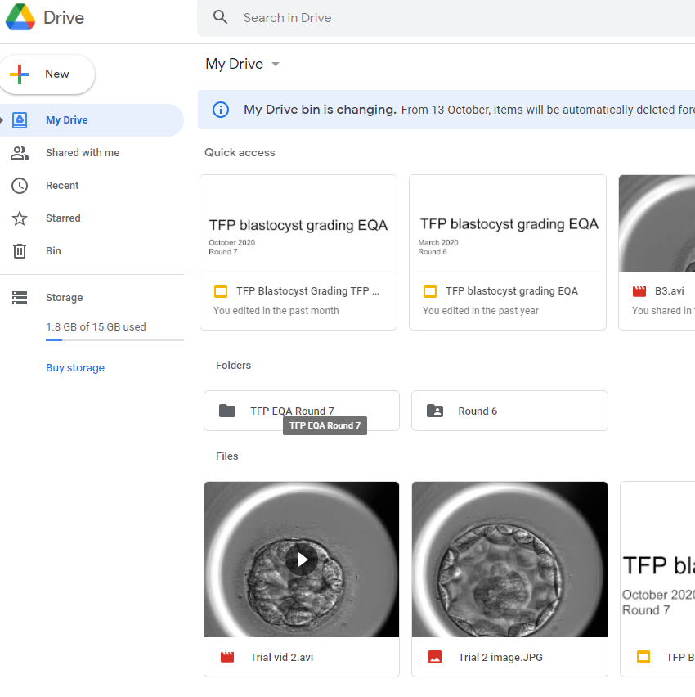
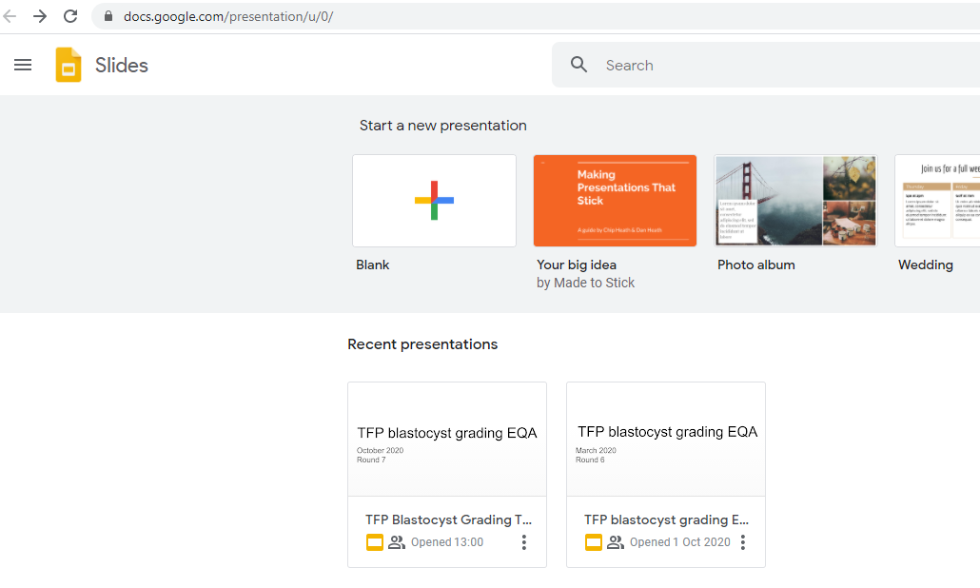
Figure 1: Google Drive and Google Slides
A ’Gold standard’ set of grades for the images is arrived at by a strict interpretation of the TFP grading scheme by the Group Embryology Director and EQA Coordinator.

5.6 To analyse the data, first amalgamate the entries from all clinics on to the same Excel sheet, recording which clinic and operator provided each set of grades and allocating each operator a unique number. Scan for any possible data entry errors by participants, for example common ones include cavitating or compacting rather than E or F or giving the choice of 2 grades. Add in a column for the Gold Standard grading and keep this sheet as ‘Raw Data’. Further copies of the Raw Data can then be made to perform the analysis. The report and raw data are then sent to Head of Labs for review and distribution.

Points for analysis may include:
            - Individual Embryologists Percentage Match to Gold Standard for Grade Allocation
For each embryologist their match score out of 35 is presented as a percentage.

            - Percentage Utilisation Agreement Compared to Gold Standard
This shows whether the embryologist chose the ‘correct’ fate (ie suitable for cryopreservation / unsuitable for cryopreservation) compared to the Gold Standard irrespective of the grading given.

            - Utilisation Rates
This is calculated as the percentage of embryos which are marked as ‘suitable for cryopreservation’. This is then compared to the Gold Standard rate.

            - Embryo Transfer Agreement
This looks at the level of agreement across all the operators without reference to the Gold Standard i.e. there is no right or wrong answer. The percentage of the embryologist who agree on the same embryo for transfer is calculated.

The EQA report is then generated and distributed to each of the laboratory managers for discussion with their teams locally.

Standards/Key Performance/Quality Indicators
% Gold Standard Match on EQA ≥70%

Monitoring
The % of grade A and B blastocysts is reviewed at the KPI meeting every 4 months.
The results of the TFP Embryo Grading EQA scheme are shared with the laboratory managers and any operators who are below the 70% gold standard match are required to re-grade the embryos.

